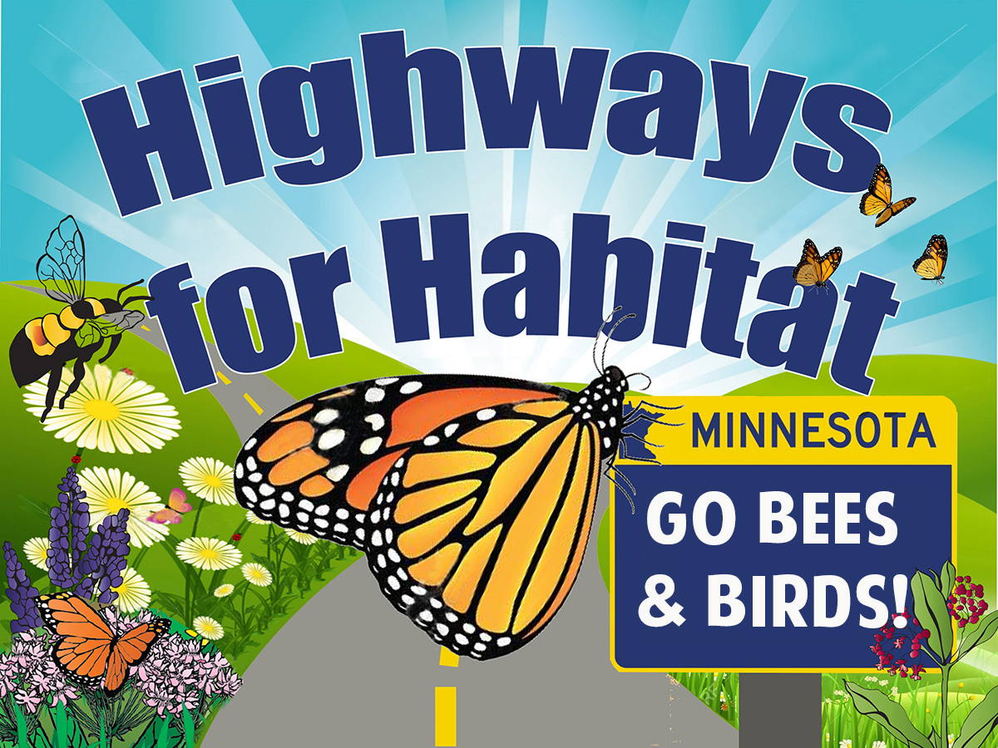
February 7: 2023 Legislative Session
For more information contact: Laurie Schneider, laurie@pollinatorfriendly.org, (651) 503-9904

Highways for Habitat says Pollinators and Birds Need Their Land Back

(Greater Minnesota) Around the U.S. native wildflower roadsides are becoming national treasures and not a moment too soon.

Pollinators and birds are struggling to find places to thrive, yet in Minnesota alone there are 135,000 miles of public lands along our roadsides offering potential habitat.

“Monarch butterflies once coursed through North America in clouds, now their migration has dwindled to a trickle,” said Brandon Keim of Science Wired. We know pollinators are in big trouble, simply turn your gaze to the skies. If pollinators and birds are to survive, they need their habitat back.

This week, a group of conservationists, scientists and land practitioners introduced a popular bill for habitat along Minnesota state highways called Highways for Habitat (Bill #HF498 / #SF718). The coalition of more than 40 national and local conservation groups including the Pollinator Friendly Alliance, Izaak Walton League, Xerces Society, Water Legacy, Wild Ones, American Bird Conservancy and Audubon Society designed Highways for Habitat to increase native habitat, improve water quality through the deep plant root systems that filter and absorb, provide erosion control for our roads, promote ecologically sound road maintenance practices and preserve Minnesota for future generations.

Minnesota is not the first to revitalize roadside habitat. Driving Interstate 35W South through Iowa, you can witness first-hand beautiful flowering corridors of native flowers and grasses, and shrub and tree buffers bordering the highway. Texas bluebonnets and the wildflowers of West Virginia and Florida count on roadside blooms to attract thousands of tourists in addition to pollinators. Other states that have planted roadside habitat and gained cost savings from reducing herbicide use and reduced mowing include Illinois, California, New York, Kansas, Washington State, Ohio, and Arizona. The state of Ohio saved more than two million dollars in just one year by reducing mowing for their roadside wildflower planting project.

The Iowa roadside program has been in place for more than 30 years. Iowa’s living roadside coordinator, Kristine Nemec, said “public opinion surveys show that people prefer roadsides with wildflowers, grasses and native trees, and communities are very concerned about pollinator conservation and water quality. Restored prairie roadsides not only offer what people want --beauty and habitat -- but eventually, the habitat become largely self-perpetuating with less cost and less maintenance. In the long run, being nature-friendly doesn't just create richer landscapes. It saves money as well.”

According to road engineer John Siekmeier of the Izaak Walton League, “this legislation is important because it enhances the ability of our highway agencies to fully deploy science-based highway maintenance best practices.”

Minnesotans want to be proud of their roadsides, too. Greg Larson of Minnetonka commutes to Litchfield weekly and has been advocating for better stewardship of our public lands.
“I’m embarrassed to live in a state with lifeless roadsides girdled by eroding fallow corn fields – what does that say about us as a thoughtful people?” he said. “I look forward to seeing lush flowering corridors along our roadways. Other states have done so, and Minnesota can too.”

Jennifer Hopwood of the Xerces Society, a science-based national conservation organization, along with other scientists and practitioners at the Federal Highway Administration have been looking at ways to improve highways for pollinators.
“Some of our last remaining remnants of critical wildlife habitat are in roadsides, especially in the corn belt where row crops are often planted inches from the highway pavement,” said Hopwood, citing a federal roadside poll. “Roadside staff reported that reducing mowing is one of the most impactful actions to protect nesting pollinators.”

This is at a time when Monarch Watch reported in January the overwintering numbers for 2022 will be the all-time lowest numbers since 2014 for monarch butterflies. (1 hectare or 2.47 acres). https://monarchwatch.org/blog/2022/01/06/how-many-hectares-in-2021-2022/
Not all roadsides are equally valuable. HIGHWAYS FOR HABITAT prioritizes the highest quality areas that have long-term ongoing maintenance, new construction, opportunities with wider native wildflower and grass corridors, and/or where existing native flower remnants already exist. Roadsides have been identified by many scientists and wildlife organizations as potential for critical wildlife habitat and migration corridors. A 2022 international study shows that biodiverse high-quality habitat along roadsides offers not only forage and nesting areas but important connectivity for migrating species. The Fish & Wildlife Service recommends roadside connecting corridors for all manner of wildlife conservation from cottontail rabbits to turtles to quail. “A quarter to a third of all the pheasants in the state are hatched in roadsides,” said Nicole Davros, DNR upland game project leader.
The National Audubon Society’s recently released Survival by Degrees report paints a dire picture of the future for birds: More than 150 species in Minnesota are threatened by the impacts of changes to Minnesota’s weather patterns. A recent study from the Cornell Lab of Ornithology also found a staggering loss of birds. Nearly 3 billion bird species are lost and grassland bird populations have declined by 53% since 1970 in the U.S. Audubon Minnesota said “By adding more native plants to highways through programs like Highways for Habitat, we can help birds in the face of changing weather, urban development, and other threats.”
Lori Cox’s Roots Return Heritage Farm in Carver, Minnesota was awarded the Minnesota Agriculture Water Quality Certification in 2016. She also serves on that advisory board for MDA, and her county's Water Management Organization. She regularly serves as an expert testifier on water, farming and conservation issues.
“As a farmer, I understand the importance of sturdy root structures to enhance water filtration for soil and moisture retention, prevent runoff of soils, nutrients, and the positive overall effects on habitat enhancement,” Cox said. “The science behind these benefits has been available for decades – there’s no reason to wait any longer for Highways for Habitat.”

There’s an urgency in Lori’s message that matches the urgency of Steve Ellis, beekeeper and President of Pollinator Stewardship Council. “The science is here, and we have seen the evidence in our state and around the world. We are running out of time – it’s long past time for Minnesota to step up and take action as pollinator species continue to decline at disturbing rates.”
What is important to understand is we know what we need to do, we have the land and resources, and it’s sustainable. Minnesotans can help pollinators and birds by contacting their representatives and Governor Walz to vote “YES” for Highways for Habitat.
Background and Citations

Coalition: who we are
We are a coalition of concerned individuals and local to national conservation organizations working collaboratively to protect pollinators, birds, and other wildlife, clean water, land and healthy food for human health.

Abbreviated list of organizations supporting Highways for Habitat
American Bird Conservancy
Audubon Chapter of Minneapolis
Audubon Minnesota River Valley Chapter
Audubon Minnesota
Bee Safe Minneapolis
Citizens Climate Lobby Minnesota
CURE (Clean Up the River Environment)
Friends of Minneapolis Wildlife
Friends of Roberts Bird Sanctuary
Humming for Bees
Izaak Walton League, Wes Libbey Northern Lakes Chapter
Lakeville Friends of the Environment
Land Stewardship Project
LONA (Legacy of Nature Alliance)
Minnesota Environmental Partnership (MEP)
Minnesota Hobby Beekeepers Association
Minnesota Ornithologists Union
Minnesota River Valley Audubon Chapter
Minnesota Well Owners Organization
Mississippi Headwaters Audubon Society
Pesticide Action Network
Pheasants Forever
Pollinate Minnesota
Pollinator Stewardship Council
Pollinator Friendly Alliance
Renewing the Countryside
Roots Return Heritage Farm
Salt ‘N’ Pepper Farm
Sierra Club North Star Chapter
Vote Climate
Ely Minnesota.com Guide to BWCAW
Water Legacy
Wild Ones St. Croix Oak Savanna Chapter
Wilderness in the City
Xerces Society for Invertebrate Conservation

Support documents, articles and scientific papers

Integrated Roadside Management Overview
https://tallgrassprairiecenter.org/roadsides

Xerces Society “Roadsides and Pollinator Conservation” video, Jennifer Hopwood
https://youtu.be/8ssfxMTBv_E

Survival by Degrees: 389 Bird Species on The Brink
Audubon

The Contribution of Roadsides to Connect Grassland Habitat for Pollinators
https://pubmed.ncbi.nlm.nih.gov/35290956/

County Roads as Habitat: The Iowa Approach video, Dr. Kristine Nemec
https://www.youtube.com/watch?v=EUGs_GkeINU

The Quiet Revolution Turning Roadsides Into Nature Reserves
https://www.wired.com/2015/04/roadside-utility-corridor-habitat/

Living Roadway Trust Fund and Roadside Habitat: Highway 35 Corridor: Federal Highway Administration https://www.environment.fhwa.dot.gov/env_topics/ecosystems/roadside_revegetation/ch08.aspx

Washington State DOT Ecologically-Based Roadside Vegetation Design and Management
https://wsdot.wa.gov/publications/manuals/fulltext/M25-30/800.pdf

Texas State Department of Transportation Vegetation Management Plan with Environmental Sensitivity
http://onlinemanuals.txdot.gov/txdotmanuals/veg/veg.pdf

Federal Highway Administration: Department of Transportation Increase Pollinator Habitat Along Roadways
https://www.environment.fhwa.dot.gov/env_topics/ecosystems/pollinators.aspx

Roadside Revegetation: integrated Approach to Establishing Native Plants and Pollinator Habitat
http://nativerevegetation.org/
Monarch Highways
https://environment.transportation.org/case_study/six-state-dots-join-forces-to-build-monarch-highway/

Illinois Transportation Forges a New Wildlife Habitat Roadside
Conservation Program
https://quailforever.org/Newsroom-(1)/2017-August/Illinois-Habitat-Highway-A-New-Partnership-for-Wil.aspx

A Massive Increase in Roadside Woody Vegetation: Goals, Pros and Cons Harvard University
https://escholarship.org/uc/item/22h2s7jt

Wildflower planting project is saving taxpayers millions in mowing Ohio

Minnesota Department of Natural Resources Roadside Protocols:
Roadside mowing law 160.232 mowing ditches outside cities
DNR Roadsides for wildlife encourages public to plant and not hay, timed mowing
1988 Roadsides for wildlife materials from DNR focus on nesting birds and avoiding mowing April-August.
Integrated roadside vegetation management techniques. (Tactics include biological, pesticides, mowing, and fire.)

Integrated Roadside Vegetation Management Technical Manual Iowa
https://scholarworks.uni.edu/facbook/116/

Lax Pesticide Policies are Putting Wildlife Health at Risk
https://www.audubon.org/magazine/summer-2021/lax-pesticide-policies-are-putting-wildlife

Roadsides Provide More Than 500,000 Acres of Nesting and Chick-rearing Habitat
https://www.crowrivermedia.com/hutchinsonleader/news/lifestyle/leisure/roadsides-are-important-wildlife-habitat/article_87490f3f-b0f0-53e6-bf5f-36f8717e6acb.html

Habitat Highways: Roadsides Can Provide Vital Sanctuaries
https://www.nwf.org/Magazines/National-Wildlife/2016/AprilMay/Conservation/Habitat-Highways

Lack of Habitat Connectivity Increases Risk of Extinction for Wildlife
https://www.jstor.org/stable/26792504

Pheasants Forever Working with Illinois DOT to Increase Highway Habitat
https://www.pheasantsforever.org/Newsroom/2017-August/Illinois-Habitat-Highway-A-New-Partnership-for-Wil.aspx

Bird Poisoning and Decline:
https://www.science.org/doi/abs/10.1126/science.aaw9419

Three Billion Birds Have BeeL in North America Since 1970
https://www.nationalgeographic.com/animals/article/three-billion-birds-lost-north-america

Roadsides are Important Habitat for Nesting Pheasants and Waterfowl
https://www.outdoornews.com/2017/07/03/pheasants-forever-ditch-mowing-roadside-disturbances/

Pesticides are Leading Cause of Grassland Bird Declines
https://abcbirds.org/article/new-study-finds-pesticides-leading-cause-of-grassland-bird-declines/

National Wildlife Federation on importance of habitat highways:
Importance of habitat highways

Pollinator Decline / Insect Apocalypse
Xerces Society: The Science Behind the Role Neonics Play in Harming Bees. Jennifer Hopwood, Aimee Code, Mace Vaughan et al. (2016)
https://xerces.org/sites/default/files/2018-05/16-023_01_XercesSoc_ExecSummary_How-Neonicotinoids-Can-Kill-Bees_web.pdf

Science, 8/3/2021, Goulson Study combines 232 scientists’ signatures to restrict neonicotinoids
Phys Org, 8/2/2021: Study shows common insecticide is harmful in any amount
https://www.mprnews.org/story/2021/02/26/npr-climate-change-deforestation-threaten-monarch-butterfly-migration

Monarch Butterflies on Verge of Extinction
https://www.nationalgeographic.com/animals/article/monarch-butterflies-near-extinction

Monarch Joint Venture Roadside Mowing Protocol:
https://monarchjointventure.org/images/uploads/documents/MowingForMonarchsUpdated.pdf

EPA National and State PCA Are Not Protecting Us From Pesticide Contamination:
The Intercept 8/7/2021: How Pesticide Companies Corrupted the EPA and Poisoned America
https://theintercept.com/2021/06/30/epa-pesticides-exposure-opp/?emci=2a58c809-74db-eb11-a7ad-501ac57b8fa7&emdi=37e67a18-27e0-eb11-a7ad-501ac57b8fa7&ceid=341111

Iowa’s Living Roadway Plant Profiler
https://www.iowadot.gov/pdf_files/plant_profiler.pdf

